Review of modern Python and JavaScript frameworks
Stephan Gazarov

Abstract
Keywords: Python, JavaScript, React, Angular, Vue, Django, Flask, Web2Py, Learning curve, Performance, Structure and Organization, Popularity, Stability, JavaScript integration, Database management, Security, Documentation.

1 Introduction
In web development, JavaScript and Python are one of the most famous languages that are used by software developers. JavaScript is commonly utilized for client-side scripting, which allows developers to add interactivity, animations, and other dynamic features to web pages. To build full stack web-applications, JavaScript is combined with NodeJS, a runtime environment that allows JS to be ran on the back-end. Python, however, is used only on the server-side. Some common uses of Python include sending data to and from servers, communicating with databases, URL routing, and ensuring security.
Essentially, the privileges of JavaScript and Python are not to be implemented without the usage of frameworks. In software development, a framework is a set of pre-written code that provides a basis for producing various applications and webpages. Their main goal is to simplify and appease the development process by providing a set of libraries, functions, and APIs. A framework serves as a foundation that developers can build their software on, rather than starting from scratch. They provide workflow improvements that include:
- Consistent structure and naming conventions / the liquidation of boilerplate code, making it easier to navigate throughout the workspace.
- Pre-built components and libraries, improving code readability and speeding up development time.
- Tools that ease debugging and application maintenance.
Nevertheless, JavaScript and Python contain an abundant number of frameworks which can all be prescribed for different purposes. Framework selection can be an ambiguous dilemma, since each one has its own advantages and disadvantages. In this review, we will be comparing frameworks for each respective language and attempt to identify a superior choice for the developer among them. For JavaScript we will review frameworks including React, Vue, and Angular and for Python we will take a look at Django, Web2py, and Flask. The criteria for the comparison are discussed below.

2 Criteria for framework comparison
The following sections will present the comparison criteria for Javascript and Python frameworks. Some criteria overlap between languages while others are language specific.. Each section will discuss different sub criteria and a reasoning for their involvement.

2.1 Learning curve
The first criterion for evaluating frameworks is the learning curve. In general, it refers to the rate at which developers can become proficient in using a particular framework. Different authors use various criteria for evaluating the learning curve. For example, Elar Saks evaluated framework syntax, architecture, data management, lifecycle, and in the ease of using third-party libraries (Saks, 2019). For example, Eric Wohlgethan evaluated the learning curve based on three subcriteria: available documentation, knowhow requirements, human resources and recruiting (Wohlgethan, 2018). The more tools a framework has, the less knowledge an individual needs to obtain (Wohlgethan, 2018). By knowhow requirements he means the amount of extra knowledge (i.e. specific language, syntax enhancements) needed to learn the framework. By human resources and recruiting subcriteria Wohlgethan cites the level of community control over the framework development. Ghimire evaluated the ease of learning of a framework based on the quality of its documentation and popularity on Stack Overflow (Ghimire, 2020). Miles evaluated the ease of learning of Python web frameworks based on his own experience of building an application (​​Miles, 2016).

2.2 Performance
The performance of a framework refers to how well it will be able to execute intended tasks, such as rendering web-pages and processing data. This is a vital criterion in the aspect of software development, since it has a significant impact on the project’s overall success, especially where speed and efficiency are crucial factors. All frameworks are built differently, therefore most of them will not perform the same way as other frameworks. Some authors do speed tests and examine framework performance on a specifically built program (Saks, 2019) (Wohlgethan, 2018).

2.3 Popularity
The popularity of a framework is also an important aspect for the developer’s tool choice. A framework with a large community means that there are more people that can help you with issues, whether on Stack Overflow, Reddit, via youtube or various tutorials. A large community also makes the framework seem more reliable and boosts its reputation, which can actually benefit an individual in the long run. The chance of a bug being found and fixed by the framework’s community before you encounter it is very likely. The popularity of the framework was accessed by Saks using data from GitHub, Stack Overflow, and NPM (Saks, 2019). Miles evaluated framework popularity based on how often it was mentioned in research papers (​​Miles, 2016).

2.4 Stability
The stability of a framework refers to its ability to generate consistent and reliable outcomes over certain periods of time, excluding the effects of unsuitable circumstances. The amount of new releases or updates (an ideal situation assumes the developers planned every future update), third-party reliance, maintenance or how effectively developers engineered this framework also play a big role in stability. The definition may vary depending on the context and goals of the framework. Wohlgethan, for example, evaluated “stability” through breaking the keyword into four different subsections, where each of them are explained using separate terms. (Wohlgethan, 2018)

2.5 Javascript integration
JavaScript integration refers to the process of incorporating JavaScript code into a larger system or software application, in other words, the framework’s ability to be compatible with JavaScript. This criteria is only relevant to JavaScript frameworks for the purposes of this review.
Different frameworks allow for usage of different languages like Javascript, TypeScript, JSX or Dart. Some frameworks only allow one main language. It is therefore crucial for the developer to select the framework based on his expertise and with enough flexibility for the development.
Some frameworks or libraries are compatible with a specific JavaScript version and the installation of particular configurations.

2.6 Security
The security of a framework can be defined by its usage to form a structured plan or approach that improves the overall security of an organization’s IT system that deals with cyber threats or attacks. It encompasses the various methodologies, best practices, and guidelines that minimize the risks associated with data breaches. In general, a security-based framework can be viewed as a compilation of international cybersecurity policies that are used to regulate the level of vulnerability to certain security-related risks. A security-based paper’s author compared frameworks' security features in various web-applications and computer languages, therefore helping software developers make important reliability decisions (Aborujilah et al, 2022). The “security” feature was also disscused in Miles’s paper (Miles, 2016).

2.7 Documentation
The documentation of a framework is vital for maximizing its effectiveness and gaining an insight on how the framework works. In general, it provides the crucial information, instructions, and guidance on how to utilise or extend the framework to meet specific needs. The documentation also includes a brief description of the framework, installation steps, underlying concepts and principles, and most importantly - the API, a.k.a the application programming interface. Ghimire discussed the documentation of Python frameworks, specifically Flask and Django (Ghimire, 2020).

2.8 Structure and Organization
The structure of a framework refers to how its components are organized and arranged to establish boundaries and enable a systematic approach towards achieving its goals. The actual structure of a framework can differ based on its purpose and the specific domain it serves. Ghimire assessed the structure of Django by examining the Model Template View (MTV) (Ghimire, 2020), while Miles assessed the stucture of Web2py by examining the Model View Controller (MVC) (Miles, 2016).

3. Javascript Frameworks

This chapter will provide an overview of each framework based on different authors’ findings in the comparison criteria listed above. Since JavaScript frameworks are the main focus, the sections will be similarly organized in terms of the learning curve, performance, popularity, security, stability, and JavaScript integration.

3.1 Learning Curve

Some JavaScript frameworks have a gentle learning curve making them easy to learn and use, while others may be more complex and may require extra time to master. Most of the frameworks include a walkthrough presentation to familiarize the user with the new software.
In his thesis, Saks evaluated the learning curve of Angular, React, and Vue based on the criteria listed in section 2.1 (Saks, 2019). In Angular, the framework’s homepage has extensive documentation and educational tutorials made for both, upcoming and experienced developers. In other words, tutorials are developed for individuals with any level of expertise (Saks, 2019). Although the tutorial on the framework’s home page was informative and covered most of the common aspects like “master/detail components, services, routing and HTTP”, knowledge obtained from this is not sufficient for industry standard knowledge (Wohlgethan, 2018). Newcomers miss out on crucial topics such as route guards, pipes, lifecycle hooks (explained deeper in the article) and others (Wohlgethan, 2018). Saks states that Angular is used with HTML and TypeScript (a language that was developed by Microsoft for a more comfortable experience with JavaScript, syntax close to Java or C#), with HTML serving as the template syntax (Wohlgethan, 2018). The framework extends the boundaries of HTML, implementing the use of some JavaScript functions into the language (Saks, 2019). Angular provides the user with a set of homogeneous API’s, so it takes time to learn everything that is offered. Since the framework predetermines many decisions for the user, the thinking processes of Angular are often described as “opinionated” (Saks, 2019). However, this situation poses an advantage for companies that hire Angular developers, since by using the functionality of the CLI, developers tend to get familiar with the code base very soon (all Angular structures are comparable) (Wohlgethan, 2018). Diving a bit deeper, Angular applications are composed of NgModules that contain blocks of code, service providers, and other code files (Saks, 2019). Every Angular app has a root module (AppModule) which launches the application, and since the root module can include an infinite amount of hierarchy child-modules, they can import and export functionality from one another (Saks, 2019). There are some cases where Angular uses the Model View Controller concept (where a root belongs to one module, and some of its precursors are imported from another module) (Saks, 2019). Another unique feature of an Angular application lies in the fact that it supports two-way data binding, a mechanism that refers to the automatic synchronization of data between the model (component or TypeScript code) and the view (template or HTML code) (Saks, 2019). Saks later evaluated the lifecycle of Angular, stating that it consists of various stages such as creation, update, and destruction (Saks, 2019). The framework provides lifecycle hooks as a way to tap into the stages of the lifecycle and run specific code. The most common lifecycle hooks in Angular are not inherently “hard” to learn, but do require some effort and attention (Saks, 2019).
In React, main concepts are thoroughly explained in tutorials located on their homepage reactjs.org, while more in-depth materials are presented in documents (Saks, 2019). Similar to Angular, the framework’s tutorials have a wide target audience (Saks, 2019). Using the JSX, aka JavaScript Syntax Extension, React can be seen as a combination of JavaScript and HTML. JSX is used for building elements that make up components which are relatively cheap to create compared to browser DOM elements (a programming interface that represents the structure and content of an HTML or XML document as a tree-like structure of nodes) (Saks, 2019). Due to using this approach, React eases the learning process and offers a certain amount of simplicity to be implemented into the development process (Wohlgethan, 2018). In addition, Saks talks about React components, which are building blocks of application and allow the UI to be “split into independent and reusable parts” (Wohlgethan, 2018). They consist of props (properties) and elements, which play crucial roles in passing data and handling components. Props are a way to pass data from a parent component to a child component, while elements refer to components or UI pieces created using JSX syntax (Saks, 2019). Furthermore, due to using the DOM concept, developers do not have to deal with how the UI transforms from one state to another (Wohlgethan, 2018). The developer only describes the expected state, since physically handling the steps to get there is React’s job (Wohlgethan, 2018). This approach severely simplifies the development and testing of various applications. In order to become familiar with React, developers are highly encouraged to have a profound knowledge of JavaScript, HTML templates, and JSX syntax (Wohlgethan, 2018). Unlike Angular, developers who work with React might have a harder time adjusting to a new project, since React’s project structures are intricate and usually vary (Wohlgethan, 2018). React is often praised for being a relatively “unopinionated” framework, allowing developers to have flexibility and freedom in their implementation choices (Wohlgethan, 2018). The addition of react.js and react-dom.js to a base HTML file may serve as an example (Wohlgethan, 2018). However, this lack of strong opinions can also lead to anti-patterns or less optimal practices if not approached with care. Additionally, React poses a dependence on third-party packages which provide additional functionality and can greatly enhance the development process (Saks, 2019). One of the most used third-party libraries is Redux. Redux is a predictable state container for JavaScript applications and allows you to centralize and manage the application state in a single location (Saks, 2019). The whole app state (refers to the state of one's application in the Redux store) of the library which can be stored in a tree-like structure, similar to that of the app component tree (Saks, 2019). In his work Saks noted that: “It might seem like overkill for smaller applications, but it will prove beneficial as the application scales up and gets more complex.” (Saks, 2019) While React provides a solid foundation, it does not enforce specific patterns or guidelines for structuring components, managing state, or handling data flow. This can result in developers taking different approaches and potentially creating inconsistencies or code that is harder to maintain and understand (Saks, 2019). Therefore, this “anti-opinionation” of React requires development teams to have experienced employees in their working spheres (Wohlgethan, 2018). Nevertheless, the React homepage provides a detailed documentation where one can view examples and live code snippets that illustrate concepts and the usage patterns (Wohlgethan, 2018). It is a valuable resource for both beginners and experienced React developers looking to deepen their understanding and improve their React coding skills.
Apart from other frameworks, Vue’s learning curve is relatively small and easy to integrate. It presents its walkthrough guide similarly, but also explains certain unique concepts in jsfiddle, an online IDE service and community where developers showcase and create new JavaScript, HTML, and CSS code snippets (Saks, 2019). The VueJS homepage has an “Essentials'' section, guide, and API where one can find an elaborate and very concise tutorial that covers all the main aspects of the framework (Wohlgethan, 2018). All Vue templates use an HTML-based syntax (Saks, 2019). By mainly using the basics of web-development and ES6 (a standardized scripting language used to write Vue applications), the framework doesn’t require any additional compilers (Wohlgethan, 2018). To be more specific, data coming from any Vue application can be binded with HTML using the Mustache syntax (this can also be used for text interpolation) (Saks, 2019). When one includes a mustache expression in the Vue template, everything written inside the curly braces will be replaced with the corresponding data value (Saks, 2019). Additionally, Vue applications are made of reusable, registered (in Vue) components called Vue instances (includes data, methods, and lifecycle hooks) (Saks, 2019). Apps are arranged in a tree-like structure. By being registered globally and locally, components are available to the subcomponents of the Vue instance tree (Saks, 2019). Similar to React, the components use the VDOM to update the page, easing the learning curve. The framework also provides a CLI (command line utility), a globally installed npm package that provides the ability to quickly scaffold and manage Vue.js projects from the command line (Wohlgethan, 2018). This approach eases the developers’ experience and helps set up a Vue.js project with a standardized file structure and build workflow (Wohlgethan, 2018). An example of these commands can be vue init <template>, <my-application-name> (Wohlgethan, 2018). Vue accepts a number of pre-configured setups (refer to predefined configurations and settings that are set for one by default) created by the development team (Wohlgethan, 2018). Such setups may be developed for applications with module bundling (like WebPack or Browserify) or configurations like Progressive Web App, aka PWA. PWA’s are web applications that utilize modern web technologies to deliver an app-like experience to users, offering additional features such as offline functionality (due to the concept of service workers), push notifications, and the ability to be installed on users’ devices (Wohlgethan, 2018). By offering a template for PWA’s, Vue emphasizes their adaption and therefore makes the learning curve much easier (Wohlgethan, 2018). Speaking of additional features, third-party libraries which enhance Vue’s functionality and features can be installed using NPM (Wohlgethan, 2018). The framework’s most popular third-party package is VueX, which is inspired by Flux, Redux, and the Elm Architecture (Wohlgethan, 2018).

3.2 Performance
The performance of a framework refers to its ability to efficiently and effectively execute tasks and handle workloads. It is an important consideration when evaluating and selecting frameworks for software development.
In his thesis, Saks evaluated the performance of three major JavaScript frameworks, building a small test application for each one (Saks, 2019). Each application had a data table and menu, with 5 main functions: create a table with 100 rows, create a table with 10 000 rows, add 1000 rows to the table, add 10 000 rows to the table, delete all rows (Saks, 2019). All three applications had the same CSS file, Vanilla JavaScript function (to produce data), and HTML template (Saks, 2019). Data for the table’s rows was produced by the buildData function in a separate file (Saks, 2019). The three speed tests were done on an Asus G73JH laptop (Windows 10 O.S.) in the Google Chrome browser (Saks, 2019). Each test measured (in milliseconds) how long it took for the browser to load the homepage and perform the 5 functions for every framework (Saks, 2019). The Angular application, which was 15.7 MB, used AWS for testing and writer’s GitHub for code reviewing (Saks, 2019). Application components were stored in multiple files, having a separate file for HTML templates, CSS styling, and JavaScript (Saks, 2019). Additionally, Angular heavily relies on third-party technologies that can boost performance, such as TypeScript or RxJS (Wohlgethan, 2018). TypeScript is a typed superset of JavaScript, which may provide further enhancements specifically in the performance criterion (other criteria as well). It can eliminate such errors as typos and incompatible types, preventing the application from crashing (Wohlgethan, 2018). Another potential benefit of TypeScript is that it can make JavaScript code more concise, efficient, and optimized for specific browsers. This leads to smaller JavaScript files, which can be loaded and executed faster (Wohlgethan, 2018). RxJS is a library for reactive programming that uses Observables (Wohlgethan, 2018). Angular utilizes Observables to handle HTTP requests and other asynchronous operations, making it easier to write code that is more responsive and efficient (Wohlgethan, 2018). Figure 1 depicts a TypeScript file that defines the App component (Saks, 2019). The file starts with an import of a few necessary dependencies through dependency injection (DI), which allows classes to request and receive their dependencies from external sources (in our case Component class from Angular core and a function for test data creation from dummyData) (Saks, 2019). The component’s properties (such as its identifier and the support files’ location) are set, and then the App component is exported (Saks, 2019).
Figure 2 shows the App component’s template , which consists of a div (with an “app” id) that can be seen as a container for two child elements, which are the app-menu and the HTML table that loops app-row components (Saks, 2019).
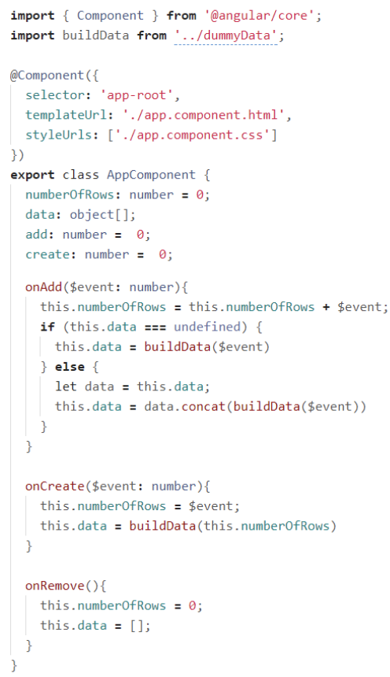
Figure 1. TypeScript file that declares the App component. Retrieved from Saks, 2019. 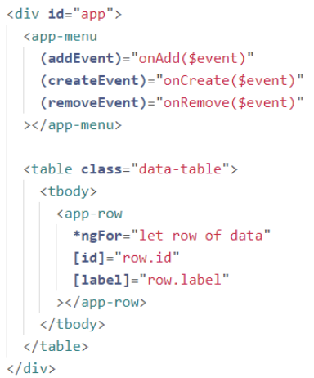
Figure 2. App component template. Retrieved from Saks, 2019.
Another key component to Angular’s performance is the menu component (Saks, 2019). It is depicted in figure 3 and contains the necessary imports from Angular core (contains a variability of imports used for Angular applications), such as the Component (used to define and create Angular components), Output (used to define output properties), and EventEmitter (allows components to emit custom events that can be subscribed by other components) (Saks, 2019). The components settings such as the template’s view and styling are set (Saks, 2019). Then comes the Menu component class declaration, which lists the methods that get returned from the component (Saks, 2019). Finally, the file ends with defining the functions that are to be returned. Figure 4 shows the Menu component’s HTML template, which consists of a header, logo, and a menu button container (each button has a unqiue method assigned by the user) (Saks, 2019).
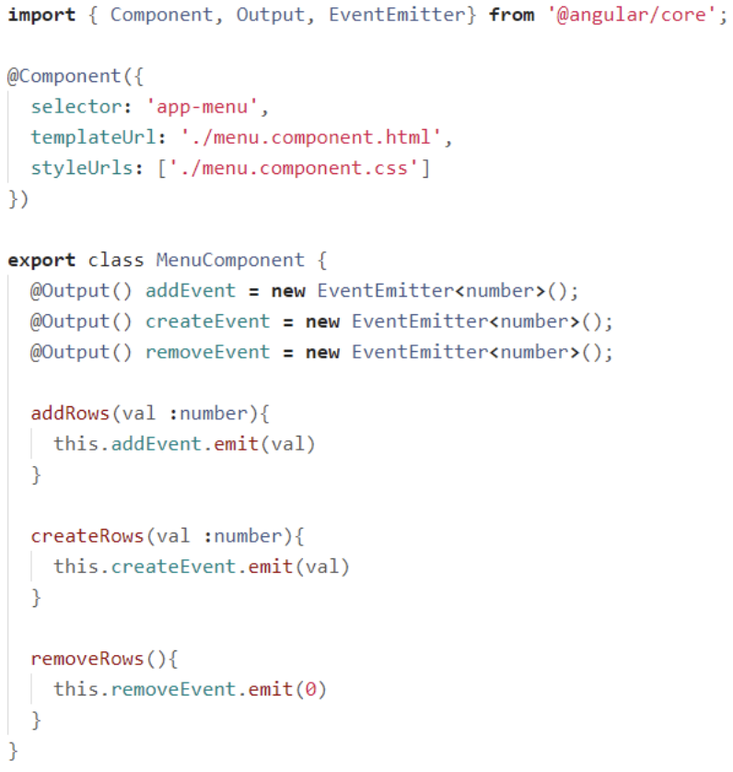
Figure 3. Menu component logic with imports. Retrieved from Saks, 2019.

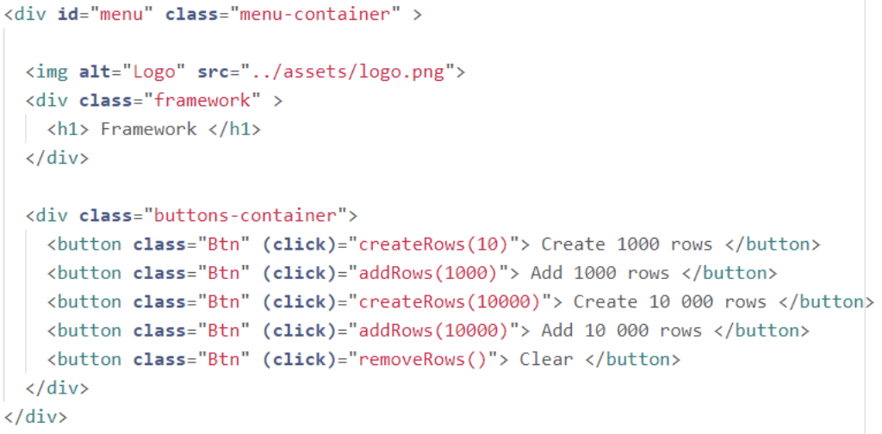
Figure 4. Menu component template. Retrieved from Saks, 2019.

The Row component logic (depicted in figure 5) is pretty short compared to others (Saks, 2019). Not having much functionality, it starts off with dependency imports and continues with component settings (Saks, 2019). It then declares the component selector, which is a property used to identify and instantiate a component within a template (Saks, 2019). The selector defines how the component is represented in the HTML markup and allows Angular to locate and render the component where it is used (Saks, 2019). The Row component ends up being exported with two data properties: id and label (Saks, 2019). Figure 6 shows that the component consists of only one table row element, which is made of 2 columns and has a few classes assigned to it (Saks, 2019).
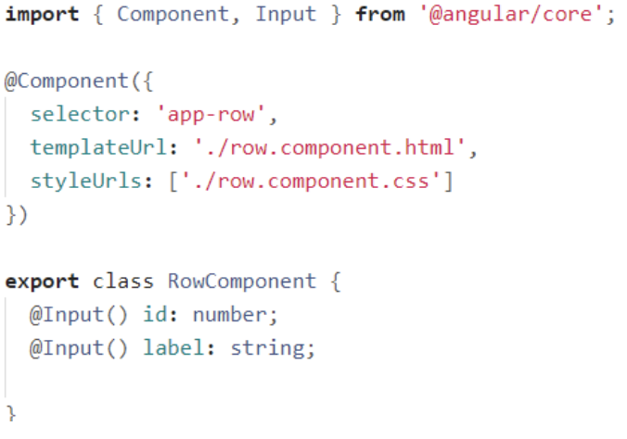
Figure 5. Row component logic with dependency imports and component settings. Retrieved from Saks, 2019.
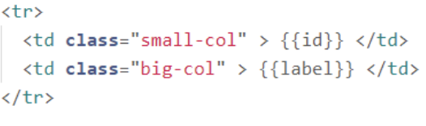
Figure 6. Row component template. Retrieved from Saks, 2019.
The table below shows Angular’s performance (speed test) results:
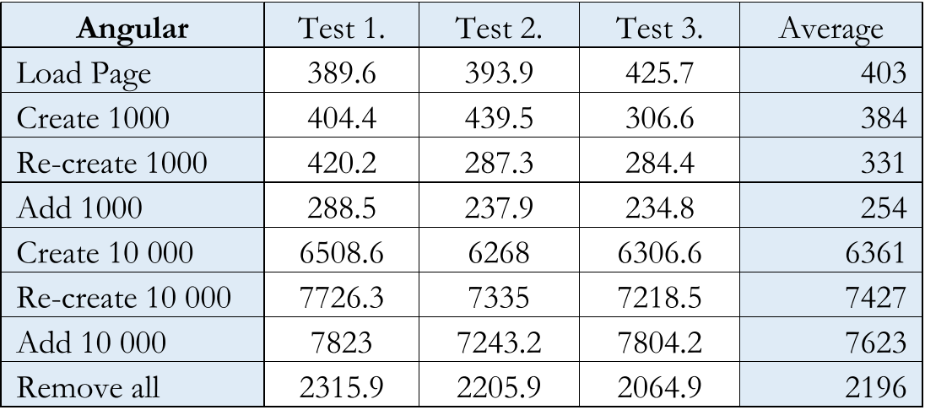
Table 1. Angular performance (speed test) results. Retrieved from (Saks et al)

The React application was 587 KB, similarly using AWS for testing and writer’s GitHub for code reviewing (Saks, 2019). Figure 7 depicts the App component, which brings the whole application together (Saks, 2019). App.js files import the dependencies, such as the Component class (from React library), CSS file, and child components (Saks, 2019). After importing the necessary modules, the App component is defined as a JavaScript class that extends the React library (Saks, 2019). Another key concept of the React Library is React’s DOM and Virtual DOM (Wohlgethan, 2018). ​​React’s VDOM is a virtual representation of the actual browser DOM that React keeps in memory (Wohlgethan, 2018). When there are changes to the UI, React updates the virtual DOM first and then efficiently determines the minimal set of changes needed to be applied to the real DOM (Wohlgethan, 2018). Due to using the virtual DOM approach, React is not only fast but also oﬀers a certain simplicity to the development process (Wohlgethan, 2018). Additionally, React components are typically divided into two sections: the component logic and the component view (Wohlgethan, 2018). Figure 8 depicts the first section. In this case, the App component is a stateful component, which means it begins with the declaration of its state (Saks, 2019). Following the state declaration, there are functions that make up component logic (Saks, 2019).
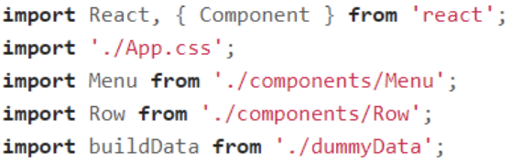
Figure 7. App component imports. Retrieved from Saks, 2019.
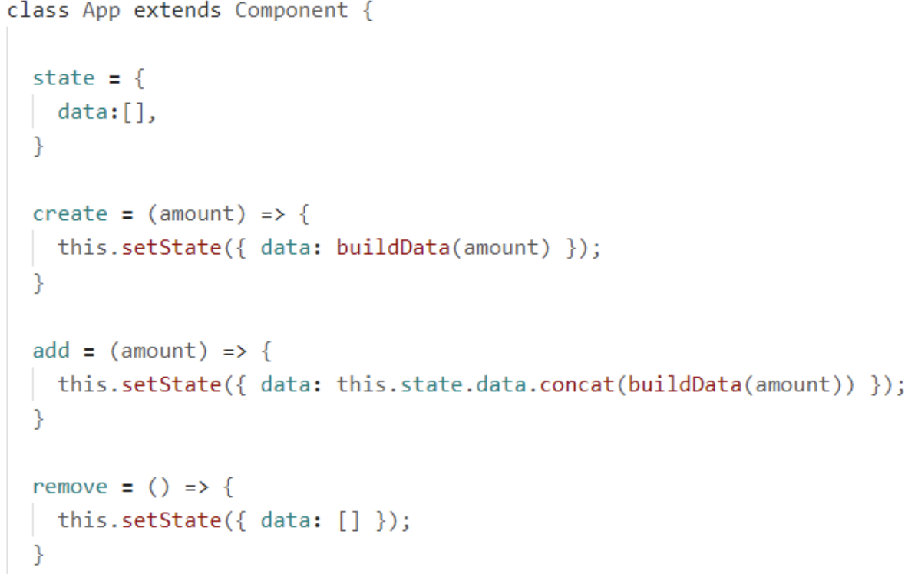
Figure 8. First part of the App component. Retrieved from (Saks et al)

The second part of the App component (figure 9) is a render function that displays the view of the App component (Saks, 2019). This view consists of a div containing a Menu component and an HTML table. The number of rows in the table is determined by the application state (Saks, 2019). The state can be modified using functions defined in the first part of the App component, which are passed as props to the Menu component (Saks, 2019). The function calls are passed from the parent to the child component, and these functions, declared in the App component, use it as the execution environment to modify its state (Saks, 2019).
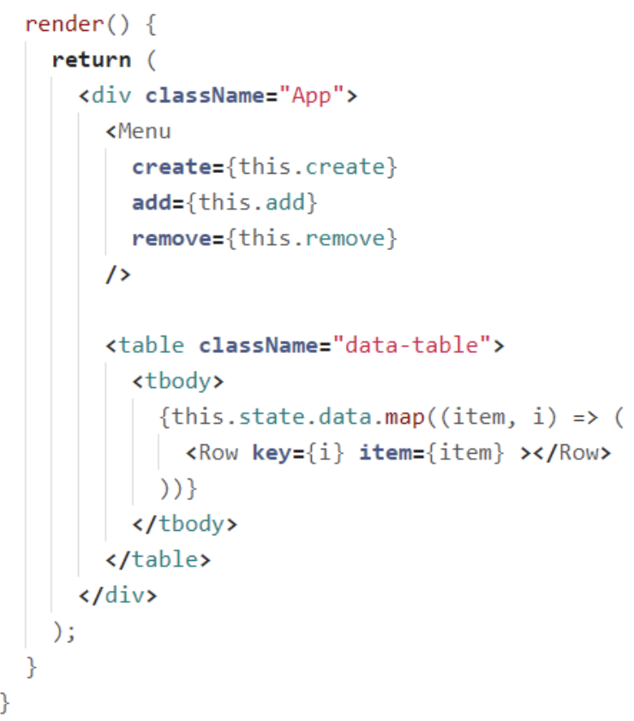
Figure 9. Second part of the App component. Retrieved from Saks, 2019.
The Menu component and the Row component are both stateless functional components (Saks, 2019). The Menu component is declared as a class in order to illustrate the outcomes, while the Row non-class component takes the properties as an input and returns a view (Saks, 2019). Figure 10 depicts the Menu component, while figure 11 depicts the Row component (Saks, 2019).
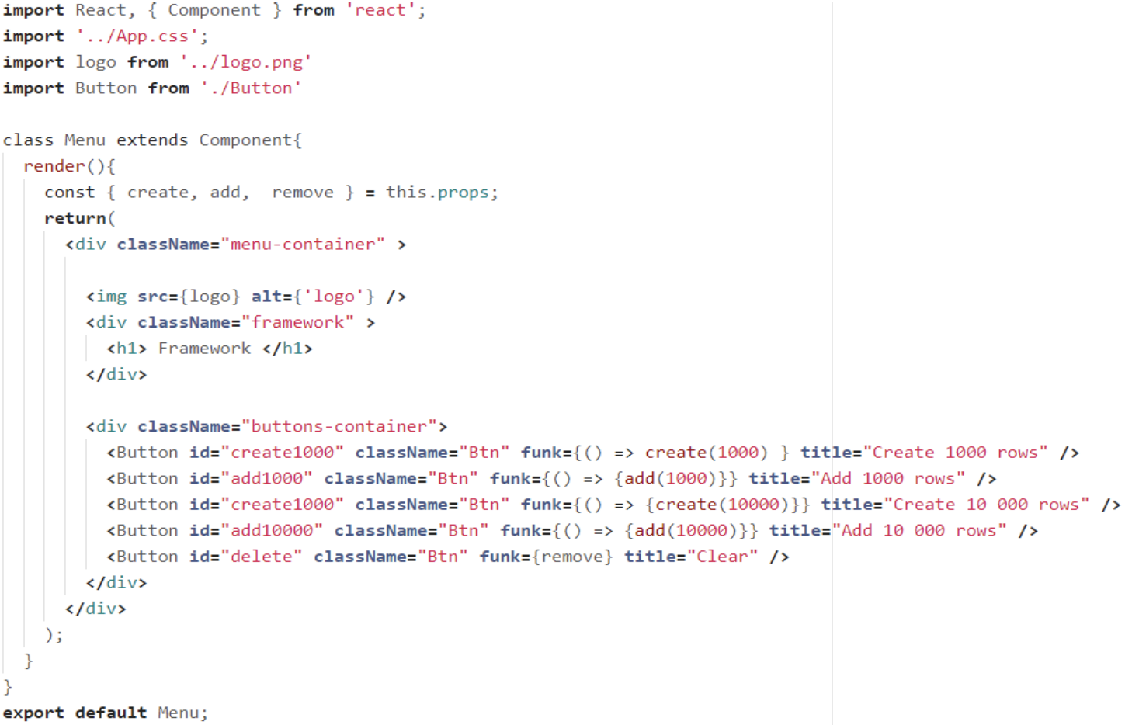
Figure 10. Menu component. Retrieved fromSaks, 2019.

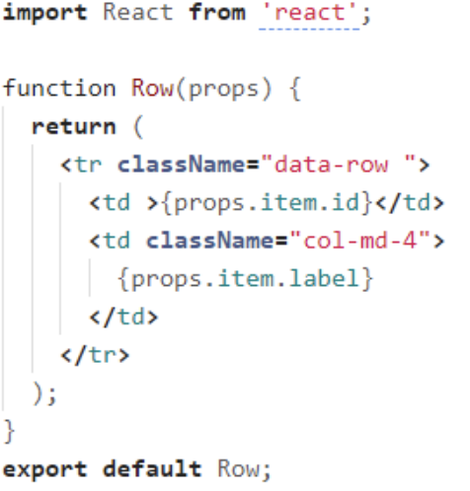
Figure 11. Row component. Retrieved from Saks, 2019.

In order for projects like these to be readable and understandable, the framework offers an API. React's API is concise and manageable, and changes to the API are implemented with circumspection (Wohlgethan, 2018). In addition, incompatible or even disruptive changes are announced in a reliable manner in advance, and APIs are retired when they are no longer necessary (Wohlgethan, 2018). This results in a robust API that is well-suited for large-scale projects (Wohlgethan, 2018)
The table below shows React’s performance (speed test) results:
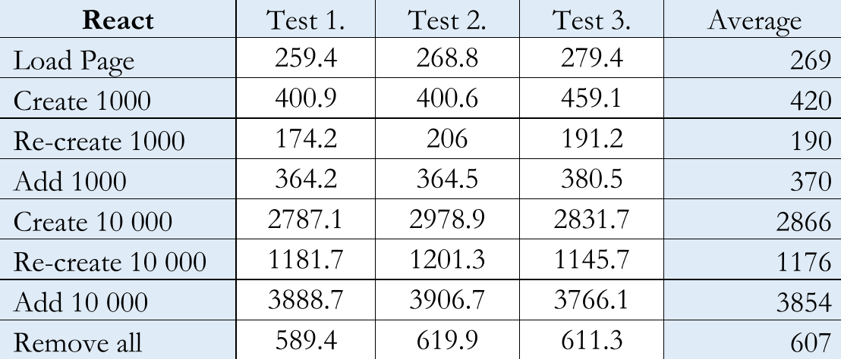
Table 2. React performance (speed test) results. Retrieved from (Saks et al).

The Vue application consists of four components: the main and root component called App, along with two child components, Menu and Row (Saks, 2019). The production build of the Vue application had a size of 624KB and is hosted on AWS for testing purposes, while its code is available on the writer's GitHub for code review (Saks, 2019). The App component serves as the root component in the Vue application and acts as the parent to the other components (Saks, 2019). It begins with a view template (figure 12), which includes an App div that contains the Menu component and a table (Saks, 2019). The table is populated with Row components based on the data property of the App component (Saks, 2019). The second part of the App component consists of a script tag containing JavaScript code that defines a Vue instance and its properties (Saks, 2019). It starts by importing the child components and the buildData function (Saks, 2019). The App component is then exported as an object that includes a data function, a components object, and a methods object (Saks, 2019). Figure 12 depicts the template, while figure 13 depicts the second half of a Vue application (Saks, 2019).
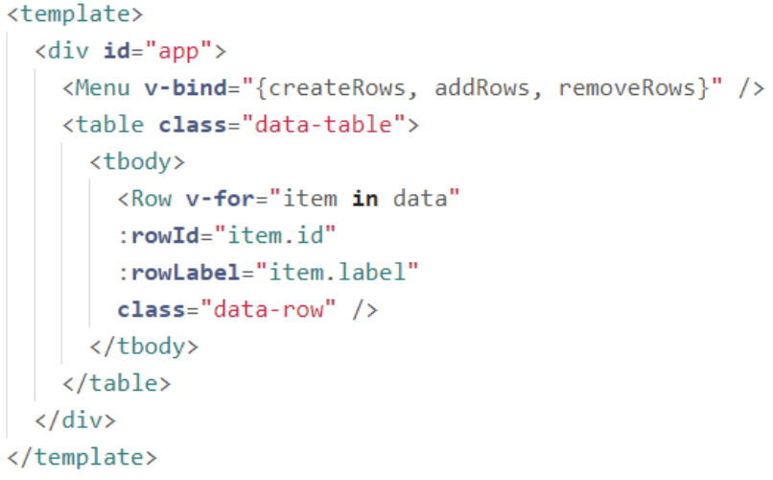
Figure 12. App.Vue application. Retrieved from Saks, 2019.
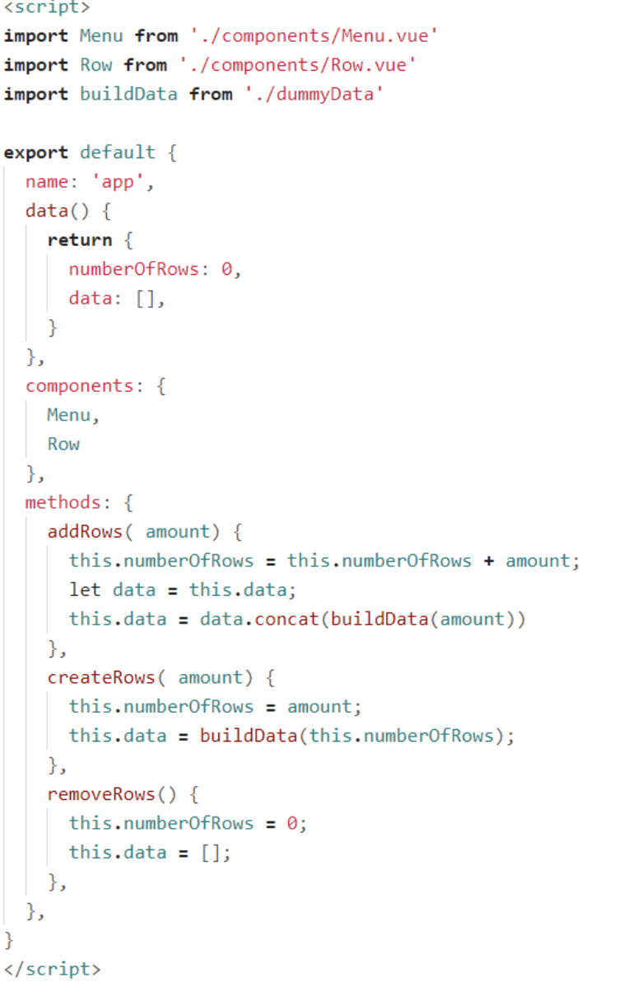
Figure 13. Second half of the App.Vue application. Retrieved from Saks, 2019.
The Menu component is made of the template part (HTML) and the script tag (JavaScript). The Row component, on the other hand, has no application logic and therefore beautifies the code. The Menu component can be seen in figure 14, while the Row component can be seen in figure figure 15 (Saks, 2019).
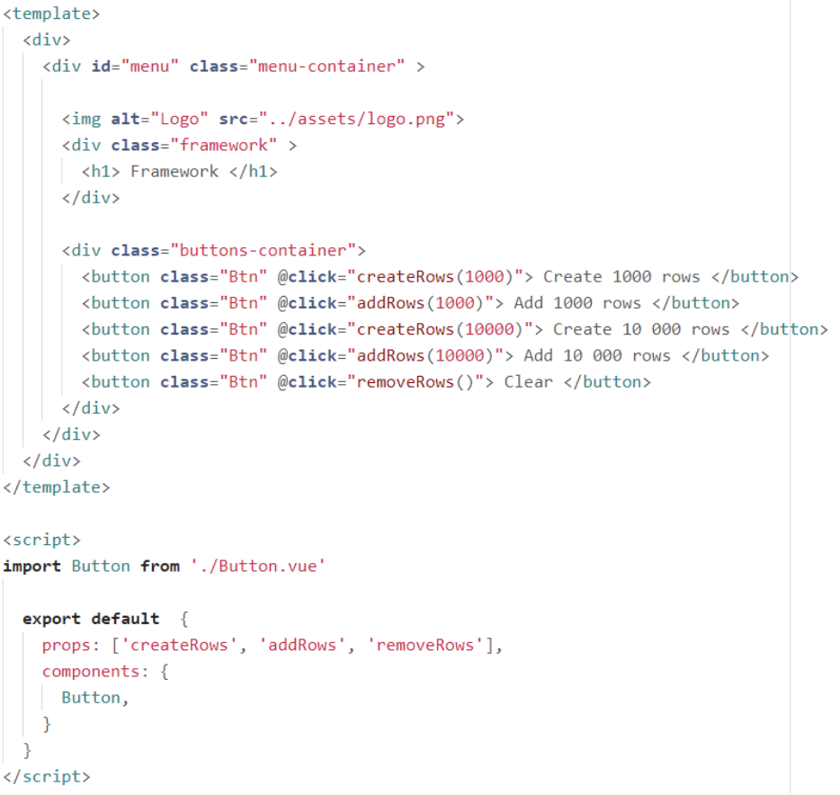
Figure 14. Menu component. Retrieved from Saks, 2019.
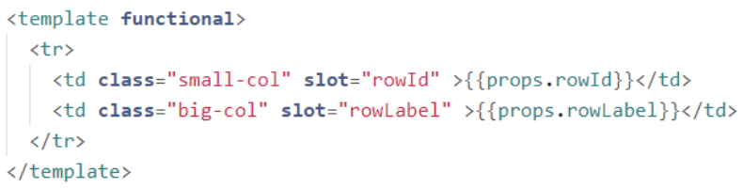
Figure 15. Row component. Retrieved from Saks, 2019.
The Vue performance (speed test) results can be viewed below:
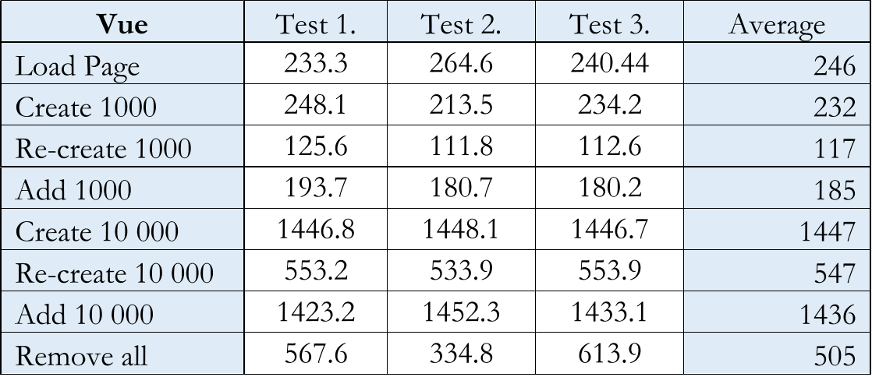
Table 3. Vue performance (speed test) results. Retrieved from Saks, 2019.

3.3 Popularity

The popularity of a framework is a dynamic phenomenon shaped with various elements, ranging from developer preferences to technological advancements and industry trends (Saks, 2019). In his thesis, Saks collected information about the popularity of frameworks from various cloud providers such as GitHub, Stack Overflow, and NPM (Saks, 2019).
GitHub is a web-based platform that facilitates version control and collaboration for software developers (Saks, 2019). It allows developers to store, manage, track, and control changes to their code repositories (Saks, 2019). GitHub is built on Git, a distributed version control system that enables multiple developers to work on a project simultaneously while keeping track of their individual changes (Saks, 2019). Table 1 displays information about Angular, React, and Vue repositories on Github (Saks, 2019).
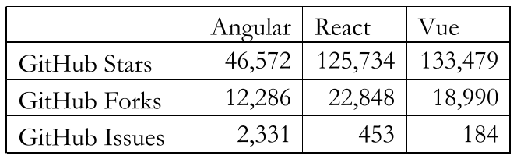
Table 4. Angular, React, and Vue repositories on GitHub. Retrieved from (Saks et al)
Repositories, in the context of software development and data management, are central locations that store and organize collections of files, code, or data. Github users mark repositories they are interested in with stars (to return later), making it easier for Github to understand what topics the user is interested in or wants to gain more knowledge about (Saks, 2019). Forking a repository is often done when one wishes to make changes or additions to an existing project without directly modifying the original codebase (Saks, 2019). It allows you to work on the project independently, providing a separate environment where you can experiment, develop features, fix bugs, or make any desired modifications (Saks, 2019). The number of forks coming out of a repository is a solid indicator of how many developers are currently working on the project for its ultimate success (Saks, 2019). Github Issues serve as a centralized system for issue tracking and project management, providing a convenient way to organize, discuss, and resolve issues in a collaborative manner (Saks, 2019). A certain amount of issues can hint on the scale of the community trying to resolve them {3].
NPM, aka “Node Package Manager” is a package manager for JavaScript that is widely used in the Node.JS system (Saks, 2019). It serves as a central hub for developers to install or manage third-party packages in their web-applications (Saks, 2019). NPM trends is a website which provides the amount of JavaScript packages downloaded via NPM, a graph of which can be seen below (Saks, 2019).

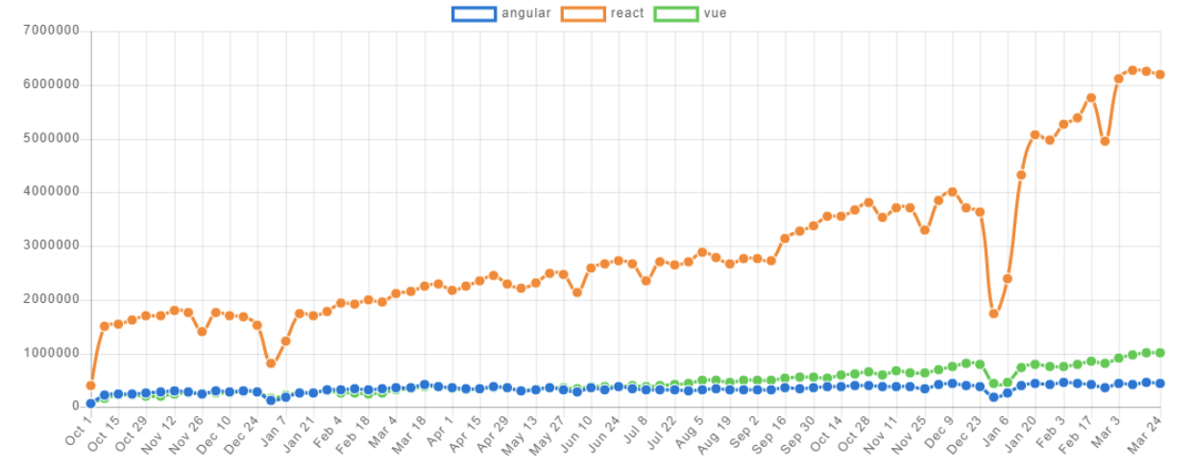
Graph 1. Amount of Angular, React, and Vue downloads via NPM during a span of two years. Retrieved from Saks, 2019.

Clearly, React is taking the lead. Angular and Vue maintain almost the same popularity, while Vue is seen to slightly increase over time (Saks, 2019).
Stack Overflow is a popular online platform where developers can address and provide an answer to questions that refer to computer science (Saks, 2019). Judging on recent studies, about 50 million users use Stack Overflow monthly (Saks, 2019). Users can post questions regarding specific programming problems, techniques, or general concepts of software development (Saks, 2019). Additionally, users can upvote or downvote both the questions and answers based on their quality and usefulness (Saks, 2019). Graph 2 depicts the amount of total questions asked about Angular, React, and Vue during the past ten years (Saks, 2019). Additionally, since Vue is a community-built framework there is a possibility that another fresh framework is published and can catch the interest of the community (Wohlgethan, 2018). In that case, the popularity of Vue could decline or even stagnate (Wohlgethan, 2018).
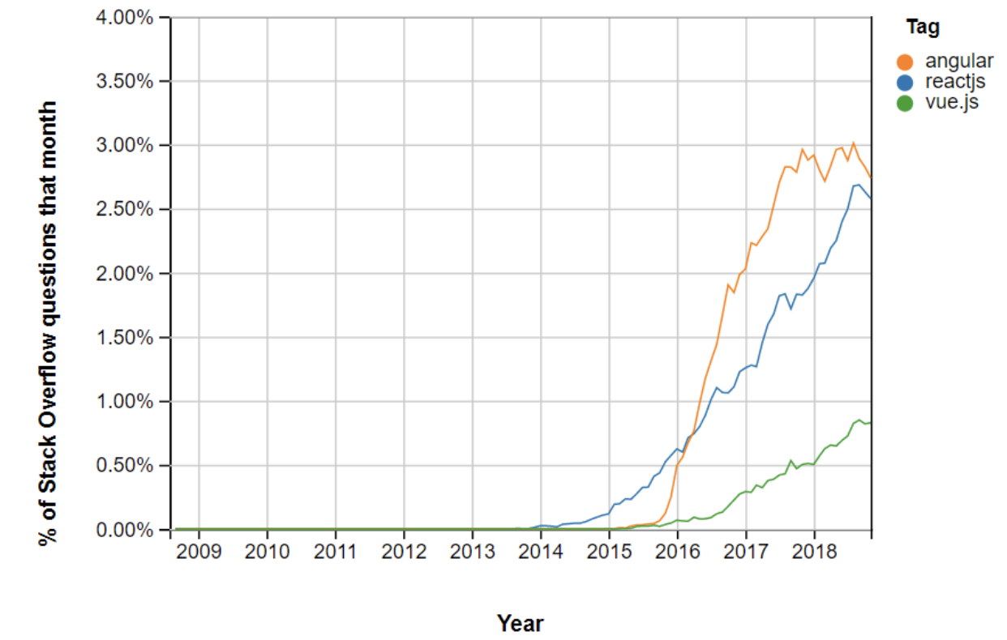
Graph 2. Percentage of total questions asked about Angular, React, and Vue via Stack Overflow during a span of ten years. Retrieved from Saks, 2019.

3.4 Stability

The stability of a framework is a measure of its ability to withstand changes without breaking. A stable framework is one that is well-tested and has a proven track record of being reliable. It is also one that is easy to extend and modify, without introducing new bugs.
In his paper, Wohlgethan explains how Angular developers depicted the framework’s chronology of versioning updates (Wohlgethan, 2018). While the original framework was named AngularJS, the rewrite was acknowledged as Angular 2 (Wohlgethan, 2018). Angular's heavy dependence on third-party packages led to many libraries labeling their software with the ng2 prefix, this caused inevitable repercussions (Wohlgethan, 2018). In September 2016, Angular changed its versioning scheme and release policy. Versions would now be released twice a year, in March and September/October, following the Semantic Versioning (SemVer) approach (Wohlgethan, 2018). This approach was originally manufactured for companies to view Angular as a more predictable and plannable framework (it provided release announcements and an online update helper) (Wohlgethan, 2018). Granting Angular a more organized versioning system, the SemVer approach consisted of three major parts: the major version (major changes), the minor version (minor changes), and the patch version (patch releases) (Wohlgethan, 2018). Since then, the Angular team has had a relatively stable versioning history: Angular 2.0, Angular 4.0, Angular 5.0, and Angular 6.0 (Wohlgethan, 2018). In the early days of Angular 2.0, the @angular/core package was at version 2.x.x, while the @angular/router package was already at version 3.x.x. Angular’s development team was abundantly criticized for this inconsistency, for it caused problems for developers who were using both packages in their js applications (Wohlgethan, 2018). To fix this problem, Angular 4.0 was made backwards compatible to Angular 2.0, meaning that one could use a more modern version of Angular with its precursor (Wohlgethan, 2018). After the release of Angular 4.0, it was no longer clear if a package with an NPM-repository prefix would be compatible with the new version (even with the backwards-compatibility update) (Wohlgethan, 2018). After thoroughly examining the situation, Angular developers decided to change the name of the framework to simply Angular (Wohlgethan, 2018). Another key aspect of the framework is that it is developed by Google (unlike many other frameworks, which are manufactured by individuals and/or the community), which serves as a huge benefit for the company during the development of certain Angular applications (Wohlgethan, 2018).
In contrast with Angular, React has been a relatively stable framework since its launch in 2013 (Saks, 2019). An exception can be made with the release of React-15 (Wohlgethan, 2018). Prior to React 15, the framework’s versions were prefixed with 0, such as 0.13 and 0.14 (Wohlgethan, 2018). This led to the misconception that versions starting with 0.x.x were not stable or production-ready, but that was not the case (Saks, 2019). React-15 introduced an abundant amount of new features and improvements, being the first version of React to be released under the Semantic Versioning scheme (Wohlgethan, 2018). This granted the framework version consistency and predictability (Wohlgethan, 2018). However, a major point of criticism has been the BSD-derived licensing of React (Wohlgethan, 2018). The BSD-derived license is known for being permissive, meaning that it allows developers to use, modify, and redistribute React without any restrictions (Wohlgethan, 2018). Furthermore, the BSD-derived license can be seen as overly permissive: for example, it allows Facebook to change the terms of the license at any time without notice (Wohlgethan, 2018). Additionally, React does not have a distinct release version for the whole framework, since most of the libraries are loosely coupled (are not tightly integrated with each other) (Wohlgethan, 2018). This can make it difficult for developers to track dependencies and ensure that their applications are stable (Wohlgethan, 2018). For example, in order to implement a routing structure into an application, there are two separate modules that need to be used: react-router and history (Wohlgethan, 2018). If the versions of these two modules are not compatible, it can cause problems for the application (Wohlgethan, 2018). The lack of a distinct release version for React as a whole can be an everlasting struggle for developers, forcing them to constantly check for dependency issues throughout their project (Wohlgethan, 2018). With regards to updatability, there have been few major problems reported (Wohlgethan, 2018). This is likely due to the stability of the official API, which makes it easy to migrate to new versions of the framework (Wohlgethan, 2018). It’s worth mentioning that incorporating third-party libraries developed by smaller teams can introduce complexities during the development process (Wohlgethan, 2018). This is due to the teams not having the resources or agility to promptly update their software to ensure comparability with new versions of React (Wohlgethan, 2018). Additionally, Facebook greatly contributes to the assurance of future releases and bug fixes (Wohlgethan, 2018). Similar to Angular, which is backed by Google, Facebook promotes the usage of React by implementing the framework in their own applications (Wohlgethan, 2018). React's overall maintainability is largely attributed to its component-based architecture, although this advantage is not unique to React as other major frameworks also utilize the same approach (Wohlgethan, 2018). However, React's strength lies in its ability to effectively handle “dumb” components, thanks to its core principles of state and props (explained above) (Wohlgethan, 2018). Additionally, React's one-way binding approach ensures a clear data flow in a single direction, making it easier to debug and maintain the code (Wohlgethan, 2018).
Unlike React and Angular, Vue is a personal project {4]. It was developed by Evan You, a former Google employee who worked on AngularJS. In 2015 (version 1.0.0), he created Vue.js as a more lightweight and flexible alternative to AngularJS (Wohlgethan, 2018). Throughout the first year of the framework’s release, statistics were quite solid:
- Code coverage of 100% on every commit since the 0.11 release, meaning that every line of code in Vue.js has been tested at least once. This is a good indicator of the quality of the code.
- More than 1400 issues have been closed on GitHub; issues were solved during an average time period of 13 hours, suggesting that the Vue community is active and engaged in improving the framework.
Due to its adoption by a plethora of large companies, Vue had to be consistent (Wohlgethan, 2018). This includes regular and transparent releases that are accompanied by extensive testing (Wohlgethan, 2018). The numbers presented by Evan You in 2015 support this claim (Wohlgethan, 2018). In comparison, the numbers for version 2.5.x of 2018 do not seem to indicate any decline: an immutable code coverage of 100%, more than 6200 issues closed with a closing rate of 6 hours (Wohlgethan, 2018). The fact that Vue is not backed by a large technology company could be perceived as a drawback (Wohlgethan, 2018). However, this also has its own merits. For instance, decisions about the future direction of the framework are not influenced by corporate interests (Wohlgethan, 2018). Instead, they are made by the community in consultation with the development team (Wohlgethan, 2018). This can lead to a more democratic and responsive development process. Nevertheless, this lack of backing could also pose a risk to the adoption of Vue (Wohlgethan, 2018). If a new framework emerges that is more popular with the community, Vue could lose its momentum (Wohlgethan, 2018). On the other hand, Google and Facebook can almost guarantee long-term commitment to their respective frameworks, both in terms of active development and financial resources (Wohlgethan, 2018). In the JavaScript world, adopting a particular technology is always a gamble (Wohlgethan, 2018). There is no guarantee that it will be successful or that it will be supported for the long term (Wohlgethan, 2018). Ultimately, the decision of whether or not to adopt Vue will depend on a variety of factors, such as the size and scope of the project (Wohlgethan, 2018).

3.5 Javascript Integration

The term “JavaScript integration” usually refers to the process of combining or incorporating JavaScript code into other technologies, frameworks, or platforms that enhance functionality and interactivity.
The use of TypeScript as a primary development language allows for the utilization of advanced ES6(a key update to JS) features, ranking it among the top five most loved languages in a 2018 Stack Overflow survey (Wohlgethan, 2018). In addition, Angular can also be used with Vanilla JavaScript and Dart (Wohlgethan, 2018). In order to have a convenient experience withTypeScript, web developers need to present a solid understanding of HTML, CSS, and JavaScript and spend more time familiarizing themselves with the framework (Wohlgethan, 2018). As mentioned earlier, Angular is a relatively “opinionated” framework (Wohlgethan, 2018). It uses Webpack 3.0 to bundle its static modules (Wohlgethan, 2018). Webpack is a module bundler released under the MIT license and widely used in the JavaScript community (Wohlgethan, 2018). One of its main advantages is that developers can write their own loaders to define what should be included in the bundling process (Wohlgethan, 2018). In the early releases of Angular 2.x.x, the development team used SystemJS internally, but later switched to Webpack (Wohlgethan, 2018). This caused some confusion, as the change resulted in inconsistent tutorials and documentation for third-party libraries, posing a problem for inexperienced developers (Wohlgethan, 2018).
React places emphasis on utilizing JavaScript, specifically ES5 and ES6 (Wohlgethan, 2018). This can create confusion in certain tutorials and online resources, as it may not always be clear which version of ECMAScript the code snippets are referring to (Wohlgethan, 2018). To leverage advanced and modern syntax features, at least ES6 or ES8 is required (Wohlgethan, 2018). Additionally, a compiler such as Babel must be used to transpile the code into a browser-compatible format (Wohlgethan, 2018). Wohlgethan further mentions that React is open to a plethora of different stacks and best practices, meaning that covering all of them is simply not possible (Wohlgethan, 2018). However, one of the most widely adopted stacks for projects includes React Router and Redux (Wohlgethan, 2018). As mentioned previously, Redux is a popular state container designed for use with React, currently gaining significant traction within the developer community (Wohlgethan, 2018). It is important to note that Redux is not the sole implementation of the Flux pattern, as there are at least 16 different packages available for state management in React alone (Wohlgethan, 2018). Evaluating the differences and merits of each of these packages can be challenging (Wohlgethan, 2018). Additionally, incorporating Redux into a project introduces additional complexity to the codebase and overall project structure (Wohlgethan, 2018).
Vue drew inspiration from prominent frameworks like Angular and React when it comes to best practices and technology stacks (Wohlgethan, 2018). For instance, the concept of a single file in Vue is influenced by React, while the idea of separating JavaScript, HTML, and CSS to ensure a clear separation of concerns is derived from Angular (Wohlgethan, 2018). One advantage of Vue is that it may not only suggest approaches to developers, but also allow flexibility for different approaches, such as organizing the mentioned technologies into separate files (Wohlgethan, 2018). When it comes to addressing state management in larger applications, the recommended library is Vue (Wohlgethan, 2018). Vue is a Flux-like implementation that can be compared to Redux in React (Wohlgethan, 2018). Once again, the developers of Vuex took an existing and well-established concept and built their own solution based on the same approach (Wohlgethan, 2018). However, it is important to note that this should not be seen as "stealing" ideas, as all the technologies involved are open source, and the community encourages building upon existing ideas and projects (Wohlgethan, 2018). Vue's success can be attributed, in part, to Evan You's expertise in web development and his ability to extract the best approaches from various aspects of modern-day applications to create a comprehensive framework (Wohlgethan, 2018). Vue mainly uses JavaScript’s ES5 and ES6 along with TypeScript (Wohlgethan, 2018).

4. Python Frameworks

This chapter will provide an overview and comparison of the 3 most popular Python frameworks: Flask, Django, and Web2py. In this chapter the learning curve, popularity, security, documentation and structure of Python will be discussed. Ghimire compared Flask and Django based on the performance of the two apps that she built. She evaluated the design pattern, requests and routing system, infrastructure and configurations, error handling, caching, flexibility, developer support. Quality of the Web2py framework was analyzed by Miles.

4.1 Learning Curve

To begin with, Flask has a relatively simple learning curve (Ghimire, 2020). With the aid of Flask's extensive documentation and the active community on Stack Overflow, the learning and onboarding process is accelerated (Ghimire, 2020). The documentation covers most of the common knowledge queries, reducing the need to seek external assistance during implementation (Ghimire, 2020). The documentation for the application can be accessed alongside other applications developed under the Pallets Project (Ghimire, 2020). Frequently, when building an application, developers face the challenge of locating precise instructions for implementing specific details (Ghimire, 2020). The official documentation serves as the primary resource for addressing this issue. Additionally, emphasis is placed on the maturity and comprehensiveness of the application in question. Flask's API is incredibly intuitive and easy to understand (Ghimire, 2020). It follows a straightforward approach, delivering on its promises without any hidden complexities found in other APIs (Ghimire, 2020). The community plays a crucial role in the popularity of open-source software applications, and Flask has gained significant recognition among Python developers on Stack Overflow (Ghimire, 2020). Currently, there are over 35 thousand tagged questions related to Flask on the platform, with accompanying answers (Ghimire, 2020). With such a vast number of posted problems, most common issues regarding framework usage can already be addressed by referring to the existing resources (Ghimire, 2020).
Django’s learning curve is a bit different (Ghimire, 2020). During the implementation of an e-commerce project, Django proves to be highly advantageous due to its comprehensive documentation, which covers a majority of the essential details (Ghimire, 2020). The documentation doesn’t even require the user to read the code in order to understand how the implementation should be done. Hence, developers can rely on the documentation for standard implementation without the need to seek external resources (Ghimire, 2020). However, there are instances where a different approach is required to solve the same problem, such as modifying the view to function differently, which may involve extensive work and necessitate in-depth investigation and source code analysis (Ghimire, 2020). The expansive range of features and support offered by the Django framework inevitably results in extensive documentation (Ghimire, 2020). Yet, developers with prior experience in Python programming are likely to grasp the framework more rapidly than those transitioning from other languages (Ghimire, 2020). Additionally, Django benefits from a vibrant and inclusive community, enabling swift assistance from fellow developers (Ghimire, 2020). As of now, stackoverflow.com, a popular platform for tech-related queries and solutions, boasts a staggering 227,839 Django tagged questions, further highlighting the platform's significance in seeking guidance and insights (Ghimire, 2020).
Miles chose to utilize Web2py for building data-driven web applications (​​Miles, 2016). Initially, he experimented with Django, the framework famously used by Pinterest, and discovered a plethora of interesting features (​​Miles, 2016). However, despite dedicating significant time to tutorials, he encountered challenges when attempting to develop applications more advanced than those covered in the tutorials (​​Miles, 2016). Subsequently, he explored Flask, a "lightweight" framework, but realized that it lacked certain essential functionalities such as built-in authentication and security groups (​​Miles, 2016). Moreover, configuring the development environment for Flask proved to be a time-consuming task (​​Miles, 2016). Ultimately, Miles downloaded web2py, and to his satisfaction, quickly set up a fully functional development environment on both his Mac and PC (​​Miles, 2016). Compared to other frameworks, Web2py eases its learning curve by bundling together the vital information one needs to get started (including the Web2py distribution and the Rocket webserver) (​​Miles, 2016). In addition, unlike most frameworks that necessitate learning a distinct templating language for the views (usually HTML files), Web2py allows you to utilize your existing Python expertise (​​Miles, 2016). In Web2py, both the controllers and templates are written purely in Python, eliminating the need to acquire knowledge of a separate templating language (​​Miles, 2016).

4.2 Popularity

A comprehensive analysis of the literature indicates an increasing user base for Web2Py framework, particularly in the field of sciences, which can be attributed, at least in part, to the widespread usage of the Python language in that domain (​​Miles, 2016). The web2py framework has been acknowledged for its role in developing water resource web applications (​​Miles, 2016). Moreover, Vanderbilt University employed web2py to create a web application that enables the rapid visualization of diverse astronomy datasets in various formats and sizes (​​Miles, 2016). Additionally, web2py was the preferred framework for building the KEGG Enriched Network Visualizer, an application that facilitates functional interpretation (at both metabolic and signaling levels) of differentially expressed gene subsets obtained from genomic experiments, serving as an integrative tool accessible to users without programming experience (​​Miles, 2016). Furthermore, researchers from Singapore and Australia utilized web2py to develop CyNote, an electronic laboratory notebook (​​Miles, 2016). Furthermore, the community’s size is big enough to sustain continuous development (​​Miles, 2016).
Even though the study by Aborujilah et al (Aborujilah et al, 2022) covered the overall security of frameworks, it also had a section about Flask’s and Django’s popularity. According to a study conducted in 2018, Express, Django, Ruby on Rails, Laravel, and Spring were identified as the most powerful and intriguing frameworks. Figure 1 illustrates a compilation of popular GitHub projects associated with backend web development frameworks, ranked based on the number of GitHub Stars at the time of the study (Aborujilah et al, 2022). Python frameworks are coloured yellow (Aborujilah et al, 2022). As one can see, Flask and Django are the most popular frameworks out of the ones studied (Aborujilah et al, 2022).
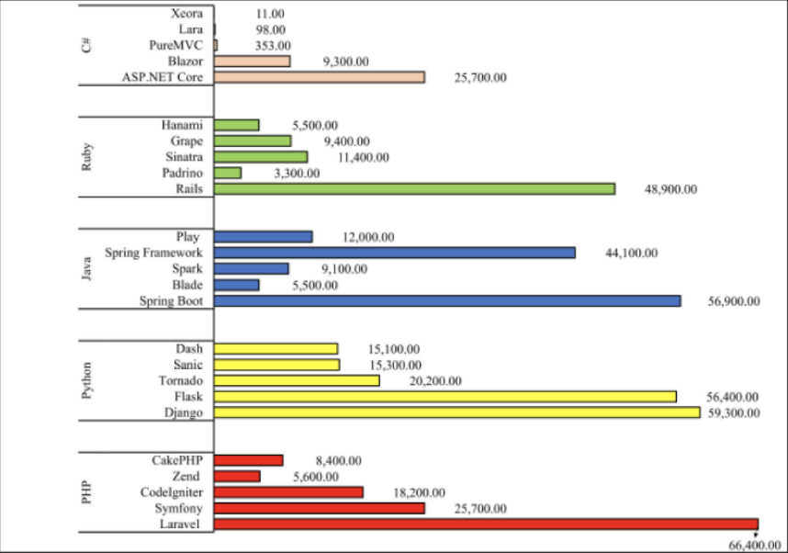
Graph 3. Most popular backend frameworks. Retrieved from Aborujilah et al, 2022.
Flask is also well known by Python developers on Stack Overflow (Ghimire, 2020). The framework’s community is engaged to answer any individuals’ question: there are more than 35 thousand Flask tagged questions with documented solutions on the platform (Ghimire, 2020).

4.3 Security

Ensuring the security of a web application is of utmost importance as it directly impacts the management and protection of user information. The internet is filled with various types of security issues and threats that pose risks to web applications. Therefore, a web application framework should prioritize adopting preventive measures and implementing best practices. This is crucial because users rely on web applications, and it is imperative to safeguard their confidential information stored on the server.
Since Flask is a microframework, it places the responsibility of ensuring application safety on the developers or implementers (Ghimire, 2020). However, there are numerous extensions available that can help address these concerns (Ghimire, 2020). For instance, an ORM extension can handle SQL injection problems effectively (Ghimire, 2020). In terms of preventing Cross-Site Request Forgery (CSRF), Flask-WTF extension provides CSRF protection specifically designed for forms (Ghimire, 2020). If a form is not utilized within the application, wrapping the app with CSRFProtect from the Flask-WTF form library can serve the purpose (Ghimire, 2020). For the user login and logout services, the framework has its own Flask-Login library that was registered in the “social.login” main view (Ghimire, 2020). During the application bootstrap, the login manager was initialized, as illustrated in Figure 16 (Ghimire, 2020).
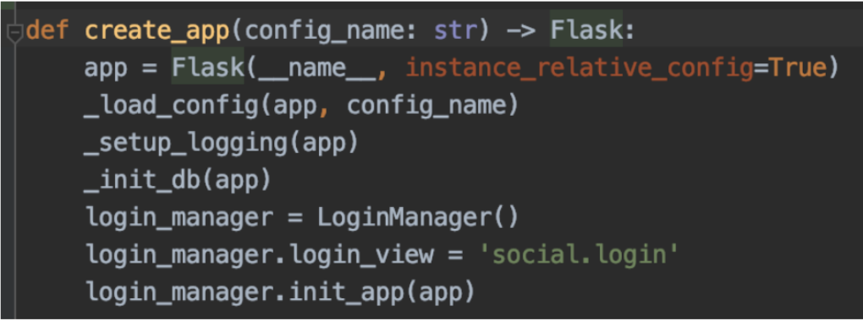
Figure 16. Application bootstrap. Retrieved from Ghimire, 2020.
Django, on the other hand, has more built-in security features and may be more elaborate than Flask on this feature (Ghimire, 2020). Due to Django being an open-source project, all of the security aspects have been thoroughly thought through (Ghimire, 2020). They include: cross-site request forgery protection (CSRF), cross-site scripting (XSS), SQL injection, clickjacking, host header validation, SSL/HTTPS (Ghimire, 2020). Django's templating system provides protection against the majority of XSS attacks (Ghimire, 2020). Additionally, for CSRF protection, Django utilizes a Csrf Middleware that verifies whether the referring header of requests originates from the same source (Ghimire, 2020). The framework also includes a built-in ORM that facilitates database querying without the need for hardcoded SQL code (Ghimire, 2020). These queries and query sets are constructed using query parameterization, effectively resolving most SQL injection issues (Ghimire, 2020). To address Clickjacking problems, Django offers a middleware called X-Frame-Options (Ghimire, 2020). Moreover, Django allows for SSL/HTTPS configuration, ensuring end-to-end encryption of requests and responses (Ghimire, 2020). The following example demonstrates how these configurations can be implemented (Ghimire, 2020). Django provides built-in protection against different types of CSRF attacks (Aborujilah et al, 2022). By default, Django utilizes a CSRF middleware that is enabled (Aborujilah et al, 2022). However, it is worth noting that sub-domains have the ability to set cookies on the client for the entire domain, thus bypassing Django's CSRF security (Aborujilah et al, 2022). To ensure protection, a CSRF secret token is required for any POST request made through a form, and this token is verified by the CSRF middleware (Aborujilah et al, 2022). While it is possible to exempt a view from the middleware's protection using the csrf_exempt decorator, it is generally not recommended to do so (Aborujilah et al, 2022).
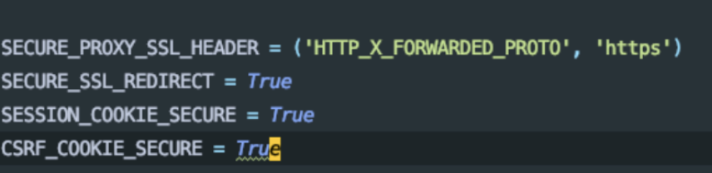
Figure 17. Django security configurations. Retrieved from Ghimire, 2020.
Web2py’s security features are quite advanced as well (​​Miles, 2016). Enabling the creation and management of user settings for security and personalization was crucial for several projects Miles was assigned to develop (​​Miles, 2016). Previously, implementing user security was a significant challenge as it had to be built from scratch (​​Miles, 2016). However, with Web2py, every project includes a built-in security scaffolding (​​Miles, 2016). This scaffolding automatically generates user, group, and security role tables, which can be easily referenced by other tables within the application (​​Miles, 2016). Additionally, the Data Abstraction Layer (DAL) in Web2py allows users to define schema definitions, which are then converted into database tables in the desired database (​​Miles, 2016). These tables are utilized to generate jQuery widgets that are serialized in HTML templates (​​Miles, 2016). The forms generated by web2py also provide automatic field validation and effectively prevent malicious SQL injection through the DAL (​​Miles, 2016).

4.4 Documentation

Flask offers a comprehensive documentation that is rich in examples and implementation details (Ghimire, 2020). This documentation is available alongside other applications developed within the Pallets Project, an organization that develops and supports Flask (Ghimire, 2020). When developing an application, developers often face the challenge of finding the appropriate instructions for implementing specific details (Ghimire, 2020). The official documentation is typically the first point of reference for finding solutions (Ghimire, 2020). Moreover, the emphasis is placed on the maturity and comprehensiveness of the application itself (Ghimire, 2020). During the application development process, the documentation provided by Flask has not presented any challenges (Ghimire, 2020). The implementation details have been clearly organized and explained precisely where they are most crucial (Ghimire, 2020). Additionally, the documentation encompasses resources on the Jinja template engine and the Werkzeug WSGI toolkit, a comprehensive library used for simplifying the development process, including routing, request and response handling, and middleware support (Ghimire, 2020). For those who are new to Flask, the documentation includes a QuickStart section that provides a step-by-step guide for building a minimal and straightforward application (Ghimire, 2020). By following the instructions outlined in this section, beginners can quickly create their first Flask application (Ghimire, 2020). The documentation is designed to be easy to read, straightforward, and easily understandable (Ghimire, 2020).
Django's documentation stands out as one of the most comprehensive and detailed resources available (Ghimire, 2020). Developers can rely on the documentation to understand how to implement features without having to dive into the code itself (Ghimire, 2020). It covers everything from getting started with Django to deploying the final application (Ghimire, 2020). The documentation also includes valuable information such as the latest release notes, details on any backwards-incompatible changes, and online discussions and topics related to development and scalability (Ghimire, 2020). Additionally, Django's documentation provides a basic tutorial specifically designed for beginners (Ghimire, 2020) . By following the instructions in the tutorial, even those new to Django can quickly bootstrap their projects (Ghimire, 2020). It's worth noting that starting from January 1, 2020, the Python Software Foundation officially ceased support for Python version 2.7. Django has taken steps to assist projects currently running on Python 2.7 in migrating to Python 3.0, providing a set of instructions for this purpose (Ghimire, 2020). The documentation is available at http://docs.djangoproject.com (Ghimire, 2020) .

4.5 Structure and Organization

When working with Django, it brings to mind the experience of working with PHP (​​Vainikka, 2018). One notable aspect of Django is that it doesn't require the use of frontend frameworks to create dynamic web services (​​Vainikka, 2018). This is because Django utilizes its own templating language called Django Template Language (DTL), which is integrated with HTML (​​Vainikka, 2018). While Django can be combined with other frameworks, it is not a necessity (​​Vainikka, 2018). Django follows the Model Template View (MTV) paradigm, which is essentially an adaptation of the Model View Controller (MVC) pattern with different terminology (​​Vainikka, 2018). In this paradigm, the model represents the data, the view displays it, and the controller manages the actions performed on the data (​​Vainikka, 2018). The user interacts with the view and employs the controller to modify the model, which is then reflected in the view (​​Vainikka, 2018). The model serves as the data storage (​​Vainikka, 2018). This concept is illustrated in Figure 18 (​​Vainikka, 2018).
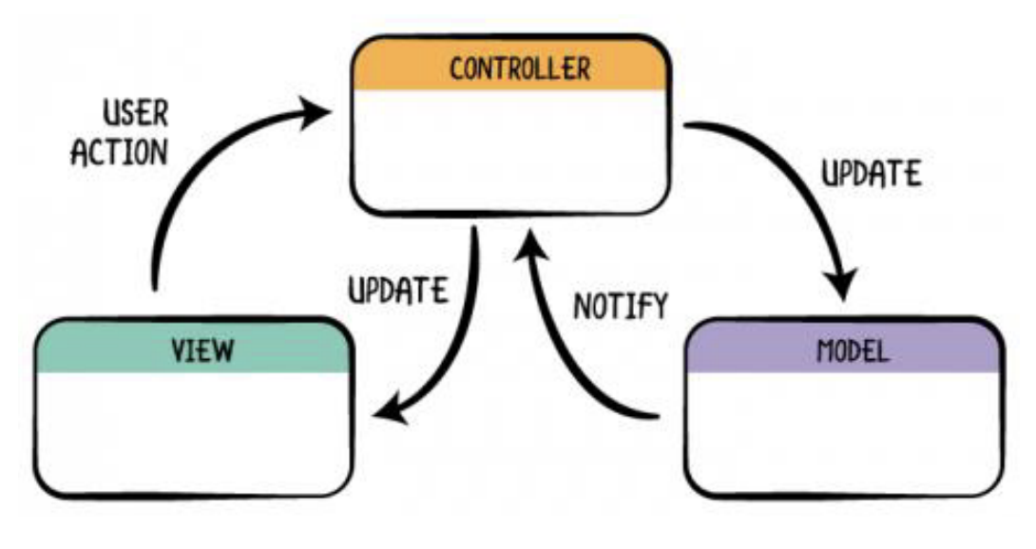
Figure 18. Model Template View. Retrieved from ​​Vainikka, 2018.
In a typical Django application, requests are directed by the urls.py configuration file (​​Vainikka, 2018). Django parses the Uniform Resource Locator (URL) and directs the data to different modules (​​Vainikka, 2018). These modules include the view (controller), data models, and templates (​​Vainikka, 2018). When creating a new Django module (app), a folder is generated with the app's name, along with the necessary file structure (​​Vainikka, 2018). Template files are not automatically created, as the views.py file can be used to render HTML as well (​​Vainikka, 2018). To enhance manageability, one can separate template folders and include HTML templates in the views.py file (​​Vainikka, 2018).
The web2py framework provides strong support for the MVC (Model-View-Controller) pattern (​​Miles, 2016). It separates data tables into model files (​​Miles, 2016). When a data table representation is created in a model file, the DAL (Database Abstraction Layer) automatically generates the corresponding table in the target database (​​Miles, 2016). The user interface, or view, is presented through HTML files, while the application logic is written in controller files (​​Miles, 2016). The web2py Folder Structure, as depicted in Figure 19, illustrates this organization (​​Miles, 2016). Each web2py application includes a pre-built menu structure known as menu.py (​​Miles, 2016). User functions can be restricted based on permissions (​​Miles, 2016). In the provided example, there are four menu options: "Upload Assignment," "View Student Assignments," "Edit/Update/Delete Student Assignments," and "Add Instructor/Course” (​​Miles, 2016). The first option is available to all users and does not require membership in any security group (​​Miles, 2016). Options two and three are only accessible to members of the Instructors group (​​Miles, 2016). The fourth option is restricted to members of the managers group (​​Miles, 2016).
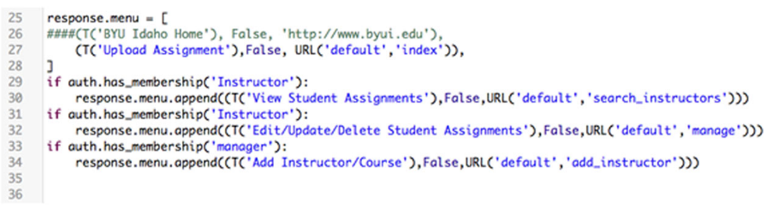
Figure 19. Menu.py. Retrieved from Miles, 2016.
Figure 20 demonstrates how this menu is displayed in the HTML template (​​Miles, 2016). When we render the HTML template, we can observe the translated string being displaye (​​Miles, 2016). The inclusion of internationalization within the web2py architecture has significantly streamlined the process of delivering applications in multiple languages (​​Miles, 2016).
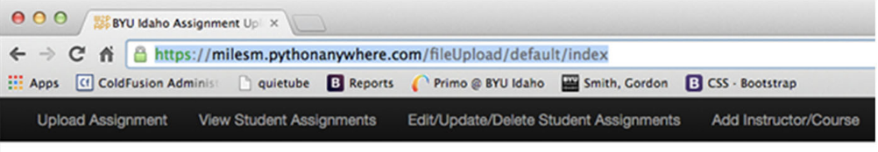
Figure 20. HTML rendering of menu.py. Retrieved from Miles, 2016.

5. Conclusion

After presenting extensive comparisons and statistical insights for both JavaScript and Python frameworks, this final chapter will revisit the question posed in the introduction chapter: is there a preferred framework option within JavaScript or Python that excels to the extent that it can be recommended for the majority of use cases?
Saks analyzed the results of the popularity section, the information for which was collected by GitHub, NPM, and Stack Overflow as of 2019 (Saks, 2019). On GitHub, Vue tended to be the most popular one, being a bit higher than React, while Angular had the lowest ranking (Saks, 2019). On NPM, React had more downloads than that of Vue and Angular combined, thus being the most popular framework(Saks, 2019) . On Stack Overflow, Angular and React’s popularity is about the same level, with Angular sparsely dominating (Saks, 2019). Due to being a newly developed framework, Vue is only slowly increasing in popularity (Saks, 2019). While Angular and React are backed up more by large technological companies, Vue is emphasized more by the community’s interests and therefore incorporates the latest and most widely adopted technological advancements (Wohlgethan, 2018). Again, as of 2019, it is safe to assert that React is the most widely used JavaScript library, given its dominance in NPM and its prominent position on Github and Stack Overflow (Saks, 2019). Based on Sak’s and Wohlgethan’s sole opinions, the learning curve was overtaken by Vue (Saks, 2019) (Wohlgethan, 2018). Out of these three options, Angular is the largest and most challenging to learn, while React follows with a slightly more complex syntax and a less comprehensive documentation (Saks, 2019). To test the performance speeds, a simple page application was built (Saks, 2019). Vue dominated this criterion by overtaking Angular and React, being 5 and 2 two times faster than them, respectively. In six out of eight tests, React showcased superior performance compared to that of Angular (Saks, 2019). High flexibility also goes to React and Vue (Wohlgethan, 2018). Additionally, React's production build had the smallest size of 587 KB, while Vue's production build was slightly larger at 624 KB (Saks, 2019). In contrast, Angular had the largest production build by a significant margin, weighing 15.7 MB (Saks, 2019). It is important to acknowledge that the performance of frameworks in terms of speed may vary as the size and complexity of the application increase (Saks, 2019). Therefore, additional testing would be necessary when dealing with more complex applications (Saks, 2019). All in all, React, being the most popular framework, is likely the best choice to learn if one is applying for a job or has an emphasis on the sole usage of JavaScript (Saks, 2019) (Wohlgethan, 2018). Vue, on the other hand, is the easiest to learn and provides fast performance (Saks, 2019). Angular, although the most challenging to learn and not the fastest performing framework, compensates for these drawbacks with its ability to excel in building large-scale applications (Saks, 2019). If one has a background in object-oriented programming or focuses on providing clear guidance and structure throughout various projects, then it is better to utilize Angular (Wohlgethan, 2018). In addition, if one is obligated to work with HTML code, it may be more beneficial to utilize Angular or Vue (Wohlgethan, 2018).
Ghimire compared Flask and Django by developing a simple web application for each framework (Ghimire, 2020). Miles evaluated his experience with web2py (​​Miles, 2016). Django is well-suited for large-scale projects, despite the harsh learning curve (Ghimire, 2020). Developers may encounter difficulties when facing problems that require advanced knowledge of the framework, since Django's documentation primarily focuses on the standard implementation of the framework (Ghimire, 2020). Django also overtook the lead in the popularity section (Ghimire, 2020). At the time of analysis, there were 227 thousand Django tagged questions on StackOverflow, while Flask had a bit more than 35 thousand (Ghimire, 2020). Flask is ideal for prototyping and small-scale projects, although it is not necessarily limited to them (Ghimire, 2020). Flask can be quickly learned and set up since it is a microframework, but it demands more effort for management and maintenance compared to Django (Ghimire, 2020). Unlike Django and Web2Py, Flask is not that proficient in the security section, but that is mainly for the reason that it is a microframework and therefore places the security-related responsibilities on its implementers (Ghimire, 2020). Django's implementation guidelines require developers to adhere to a specific approach when coding, which can sometimes make it difficult to make small changes that would otherwise be beneficial (Ghimire, 2020). This is due to the technical implementation not always supporting these changes, therefore making the framework not that suitable for small-scale applications (Ghimire, 2020). Flask and Web2py, however, are more flexible (Ghimire, 2020) (​​Miles, 2016). Web2py seemed to be the easiest one to handle regarding the learning curve, especially since Flask and Django do not have everything bundled up in their framework’s distribution (​​Miles, 2016). Web2py also doesn’t have its own template language for template files (typically HTML), allowing the user to use his expertise that he might already have with pure Python (​​Miles, 2016). While not having as many security features as Django, web2py still has its own security scaffolding that is integrated into every project one creates, eliminating the possibility of having to manually write all of the security features from scratch (​​Miles, 2016). Web2py, however, is not that popular and has significantly less support than Django and Flask (​​Miles, 2016).

References

Aborujilah A., Adamu J., Shariff S. M. & Long Z. A. (2022). Descriptive Analysis of Built-in Security Features in Web Development Frameworks. Proceedings of the 2022 16th International Conference on Ubiquitous Information Management and Communication, IMCOM 2022. https://doi.org/10.1109/IMCOM53663.2022.9721750
Devndra G. (2020). Comparative Study on Python Web Frameworks: Flask and Django. Bachelor's thesis. Metropolia University of Applied Sciences. Retrieved from https://www.theseus.fi/bitstream/handle/10024/339796/Ghimire_Devndra.pdf?sequence=2&isAllowed=y.
Miles, M. (2016), "Using web2py Python framework for creating data-driven web applications in the academic library", Library Hi Tech, Vol. 34 No. 1, pp. 164-171. https://doi.org/10.1108/LHT-08-2015-0082
Saks E. (2019). JavaSript Frameworks: Angular vs React vs Vue. Thesis. Haaga-Helia University of Applied Sciences - Pasila campus. Retrieved from https://www.theseus.fi/bitstream/handle/10024/261970/Thesis-Elar-Saks.pdf
Vainikka, J. (2018). Full-stack web development using Django REST framework and React (Bachelor of Engineering thesis). Metropolia University of Applied Sciences, Helsinki, Finland. Retrieved from https://core.ac.uk/download/pdf/161428038.pdf.
Wohlgethan E. (2018). Supporting Web Development Decisions by Comparing Three Major JavaScript Frameworks: Angular, React and Vue.js. Bachelor's thesis. Hamburg University of Applied Sciences. Retrieved from https://reposit.haw-hamburg.de/bitstream/20.500.12738/8417/1/BA_Wohlgethan_2176410.pdf

